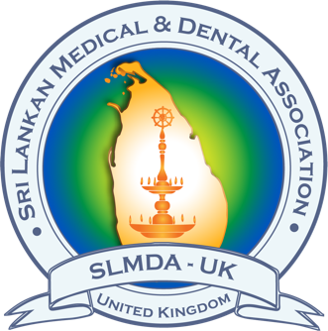
Sri Lankan Medical and Dental Association - Spring Scientific Meeting

at Delta Hotel by Marriott, Worsley Park Country Club, Manchester, M28 2QT, UK
on 03rd May (Sunday), 2026
Deadline for submission of abstracts - 31st March 2026
Email to: mahengonsal@gmail.com

CORRESPONDING AUTHOR DETAILS

Current post (if working) or the year of study (if student) |  | (e.g. Student - Year 3)
Place of work |  | (e.g. University of Manchester)
SLMDA contact, if any
Email Address |  |  | Tel
ABSTRACT
Abstract title

Type of Presentation | Please mark with a cross (x)  - Audit ( )  - Case report ( )  - Literature review ( )  - Other ( )
List of authors | First name in lower case, SURNAME in upper case, ; Please underline the name of the presenting author. (eg, Hasini BANNEHEKE, Niroshini NIRMALAN )
Copy & paste the abstract here. (Use Times New Roman, size 10 font, 250 words)

YOUR PREFERRED PRESENTATION TYPE: Please mark with a cross (x)
Oral (10 min presentation of PowerPoint slides, 4 min for questions)
Poster
The selection committee will have final authority over acceptance decisions and the most appropriate presentation format. Accepted abstracts will be published in the Proceedings Book and may be cited. The Founders’ Prize will be awarded to the best oral and poster presentations, as determined by the judging panel.

