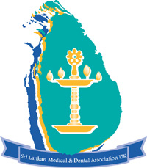

**Council 2016- 2017**

**President**

Dr Melanie Weerasuriya

**Vice President**

Dr Ruwan De Soysa

**Secretary**

Dr Supul Hennayake

**Treasurer**

Mr Mahadeva Manohar

**Council members**

Dr Lankanatha Alwis

Dr Roshan Amarasena

Dr Asanga Fernando

Dr Udara Kularatne

Dr Janaka Weeratunga

Dr Susantha Wijayasiri

**Immediate Past President**

Prof Mahesh Nirmalan

**Co-opted members**

Mr Ajantha Jayatunga

Dr Andrew Nayagam

Dr Thushara Rodrigo

Prof DYD Samarawickr**a**ma

Mr Allistair Solomonsz

Dr Champa Sumanasuriya

**Advisory Committee**

Dr Sathi Ariyanayagam

Dr Auffer Asver

Dr Rasieka Jayatunga

**UK Charity No 800821**

[**www.srilankan-mda.org.uk**](http://www.srilankan-mda.org.uk)

Registered address

152, Old Woking Road

Woking

Surrey GU22 8LE

**Address for correspondence**

**6 George Street**

**Hounslow**

**Middlesex**

**TW3 4NB**

**Sri Lankan Medical and Dental**

**Association in the UK (SLMDA)**